一、485固件升级
一．485 firmware upgrade
- 连接好电表的485以及电脑，仪表上电
1. Connect the 485 of the meter and the computer, and the meter is powered on
- 打开485固件升级文件夹，打开图标所指的软件
2. Open the 485 firmware upgrade folder，Open the software that the icon points to
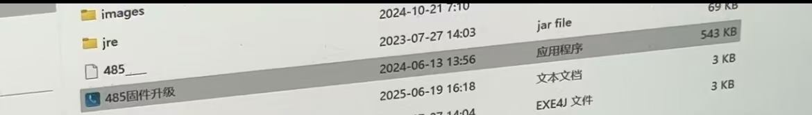
- 串口配置需要如图，然后点击所指按钮
3. The serial port configuration needs to be as shown in the figure, and then click the button pointed out
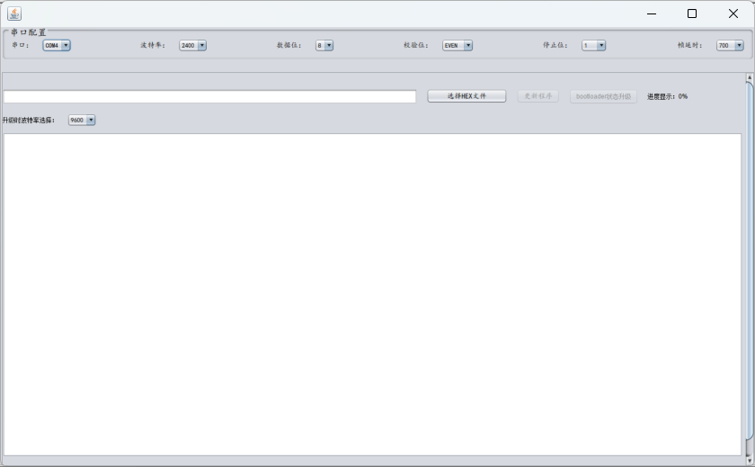
- 选择发送给您的该文件
4. Select the file sent to you
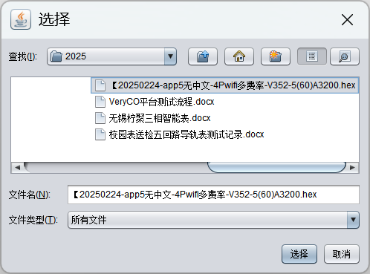
- 显示以下界面后点击
5.Click on the following interfac
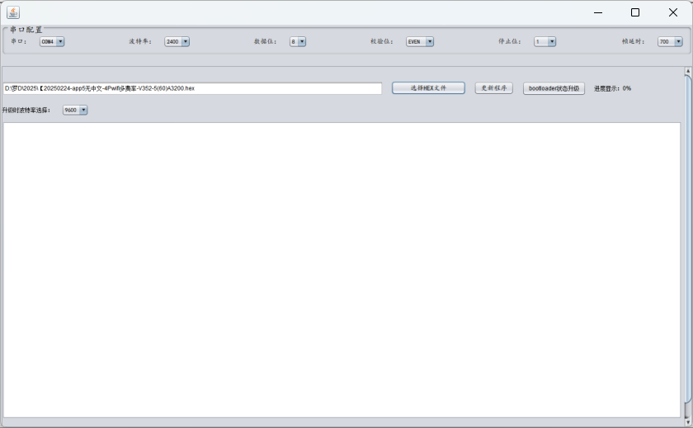
- 等待程序自动升级，升级完成显示以下界面
6.Wait for the program to be upgraded automatically, and the following interface will be displayed when the upgrade is complete
